Saint Peter’s Basilica or The Papal Basilica of Saint Peter in the Vatican is a well-known tourist spot when one visits Vatican City. It is a church built during the Reneissance era. Great contributors who designed the Basilica are Michaelangelo, Bernini, Bramante, and Maderno. These are architects and sculptors that are known amongst the Arts. The Basilica is actually the largest church in the world. The Basilica now is not the original one, it’s actually the second one. It was established by Pope Julius who persuaded Michaelangelo to design a new one (Walksofitaly, 2012).

Designed by Gian Lorenzo Bernini, Michelangelo, Donato Bramante, and Carlo Maderno, The Basilica of St. Peter is a renaissance-styled church built in 1506. Outside the basilica is the *Piazza San Pietro* (St. Peter’s Square). It is a huge oval framed by two colonnades of 284 Doric columns and 88 pillars in four rows, and 140 statues of saints are found on top of those. The 650-foot-long oval is said to represent the “motherly arms of the church”. An obelisk can also be found together with two identical fountains that lie on the axis of the oval. 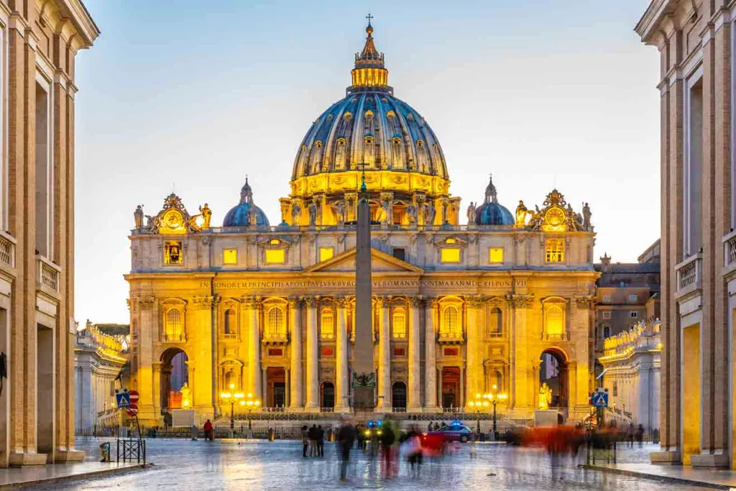

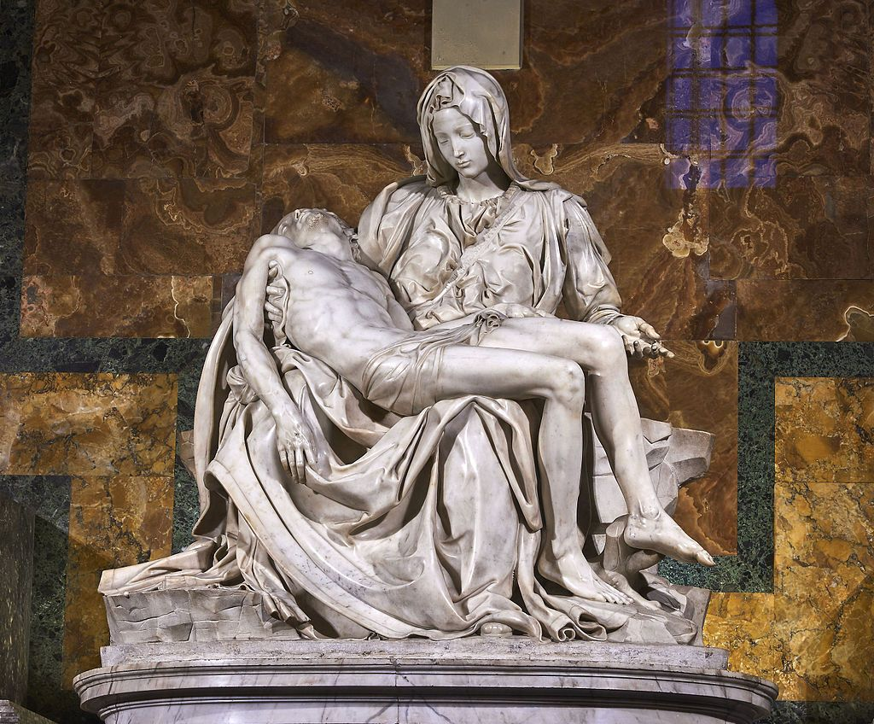

# **Statue of Basilica**

Before entering the Basilica, the statue of Saint Paul can be seen which shows a figure of him standing and holding a piece of paper which is assumed to be where the scriptures or his teachings are written. As you enter the Basilica, the chapel of the Pieta can be found. The Pieta is a sculpture that illustrates the mother of Jesus carrying Him in her arms after He was crucified. Since a mentally disturbed man broke Mary’s arm and nose, the Pieta is protected by the bulletproof glass panel. Aside from sculptures, the reproduction of there are paintings which can also be seen inside the Basilica. The first painting showed in the video is located particularly at the altar of transfiguration. The painting represents the transfiguration where it can be seen that Christ is elevated in the clouds and both Moses and Elijah are on His side. According to the video regarding the virtual trip to the basilica, the artworks inside may look like paintings but they are actually mosaics.

# **Inside of Basilica**

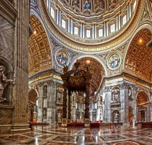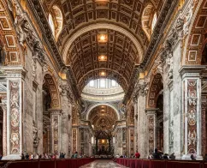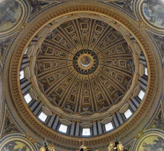

The interior of St. Peter’s is filled with many masterpieces of Renaissance and Baroque art, among the most famous of which are Michelangelo’s *Pietà*, the Baldachin by Bernini over the main altar, the statue of St. Longinus in the crossing, the tomb of Urban VIII, and the bronze cathedra of St. Peter in the apse. The majestic interior, designed in gold, shining in a mass of rare marble that is also dazzling with mosaics. The architecture, painting, sculpture, the art making mosaic, of casting bronze have that gives off a lot of attention to their beauties and treasures on it. It has a capacity of over 60,000 people, covers 22,300 square meters and is one of the world’s largest churches. The interior of the church is large with a surface area. This area can accommodate up to over 60,000 people. The ceiling to the floor consists of a large middle dome and a coffered cask catacomb. The first impression someone gets from the interior is that the church is wealthy, as manifested in the large monuments that decorate the church.

Upon entering the church, you will be in the Atrium which is richly decorated with stucco and medallions depicting scenes from the construction of the Old Saint Peter’s Basilica, with statues of the first thirty two martyred popes is so noble and majestic as to seem like a basilica itself. It was designed by Maderno in 1612, with elegance and grace. It is 71 meters long, 13 meters wide and 20 high. Inside, the basilica is designed  with an elongated nave in the form of a Latin cross. The nave is framed by wide aisles giving access to a number of chapels. These include: the Chapel of the Presentation of the Virgin, the Clementine Chapel, the Chapel of the Madonna of Colonna, the Gregorian Chapel, the Chapel of the Pieta, several other altars and beneath the high altar, is the Chapel of the Confession.

The architectural impression of Saint Peter’s Basilica is rather impressive. The central area of the church that includes a lobby is 694 ft long. The church’s dome is the largest in the world with a diameter of 42 meters and a horizontal length of 434ft (Doyle 146).A noticeable feature of the church design is the 149 ft tall front elevation. Carlo Maderno designed the facade from a slight alteration of an original design by Michelangelo. The original design intended to have colossal columns in front of the building, but the new design placed the columns adjacent to the walls (Doyle 148). When you look up, around the nave are colossal statues of the founders of different religious orders and the letters on the wall came from Matthew 16:19

**Overall Experience About Basilica**

My Saint Peter’s Basilica experience through a virtual video was absolutely astonishing from the wall designs and their details, monuments, paintings and the canopy that all relate to St. Peter’s experiences. From the moment I virtually entered the Saint Peter’s Basilica I was instantly captivated by the largeness and wall designs of the structure. The details of the wall designs and how they were organized were aesthetically appealing to the eyes and I had that feeling that I am really in a religious church despite it being shown in a virtual video. When I was touring around, The second thing that caught my eye was the monuments and sculptures that were placed in a certain section of the church and were hung on the wall. I could clearly see that the monuments and statues each hold a significance through the life of St. Peter and I really like how they are placed in a certain corner for every individual to perceive each monument and statue. The highlights of the St. Peter Basilica church for me was the canopy at the center of the shrine. It was the first large canopy I’ve seen and the details of the structure was so mesmerizing that it was eye-catching even from afar. I also like how it was placed at the very center of the church to show significance where St. Peter’s tomb lies too. Overall, the experience was really an ambiance that was different compared to the other churches because there were certain emotions and feelings specifically being amazed and feeling genuinely connected to the shrine during the virtual walk in the St. Peter’s Basilica. Every second was definitely a memorable experience despite it being a virtual video and it would be an honor to perceive the St. Peter’s Basilica in person in the future.